**Introduction to the Investment Climate**

Investment is conventionally described as the "dedication of resources for future gains." When money is involved, it can be construed as the "allocation of funds for prospective monetary returns." Taking a broader stance, investment can be defined as the "adjustment of resource expenditure and receipt patterns to optimize desired flows." When articulated in monetary terms, the net monetary receipt over a specific timeframe is denoted as cash flow, and a sequence of money received over multiple periods is termed a cash flow stream.

In the financial domain, the fundamental aim of investing is to yield a return on the invested asset. This return may encompass a gain (profit) or a loss incurred from the sale of a property or investment, unrealized capital appreciation (or depreciation), investment income such as dividends, interest, or rental income, or a composite of capital gain and income. The return may also factor in currency gains or losses stemming from fluctuations in foreign currency exchange rates.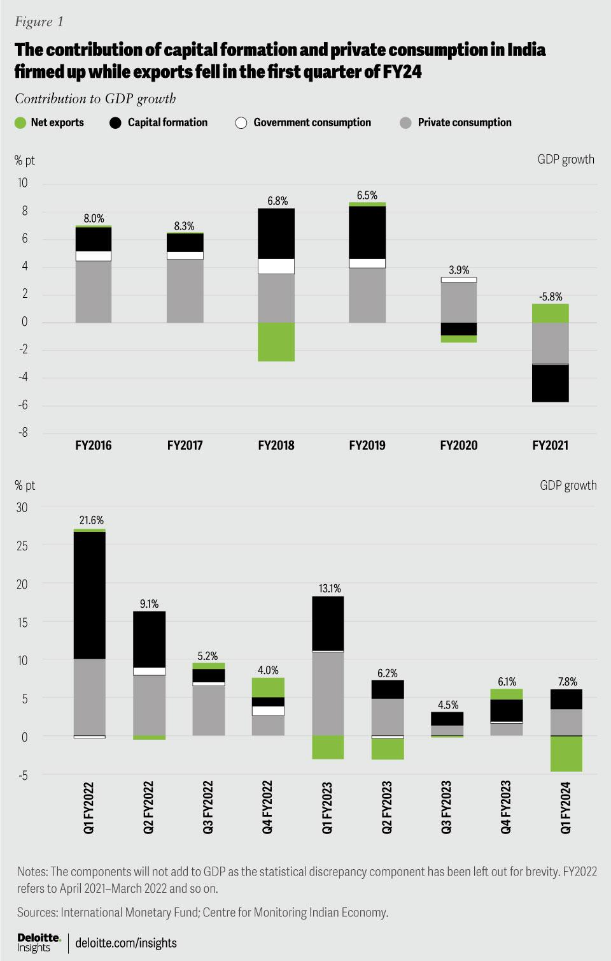

Investors typically anticipate elevated returns from ventures carrying higher risk. Low-risk investments commonly yield more conservative returns, while ventures with increased risk entail the prospect of substantial losses.

Investors, especially those new to the arena, are often recommended to diversify their portfolio. Diversification, from a statistical standpoint, functions to mitigate overall risk associated with investments.

In summary, the nexus between investment and risk is pivotal in the financial landscape, where the quest for returns is counterbalanced against the potential for financial exposure and losses.

**Indian investment scenario.**

In the initial quarter, India experienced a growth of 7.8%, closely aligning with the Reserve Bank of India’s (RBI’s) projected figure of 8.1%. A significant portion of this expansion was driven by robust domestic demand, even in the face of the global economic slowdown that exerted pressure on exports, causing a 7.7% contraction. This decline, impacting a range of sectors due to subdued demand, was notable; however, the electronics goods segment bucked the trend, sustaining strength. Over the last two years, its contribution to total exports surged from 3.4% to 7.2%, supported by the worldwide trend towards accelerated digitization and India's committed push for self-sufficiency in the electronics domain.

Private sector investment demonstrated a year-on-year growth of 7.8%, maintaining a consistent upward trajectory witnessed over the past five quarters. This upswing was aided by the government's increased capital expenditure, creating a crowding-in effect. A particularly noteworthy development was the robust resurgence of private consumption, recording a 6% growth after two quarters of lackluster performance. The relatively restrained consumer spending had restrained private investment to some extent. The strong growth in consumption during the first quarter is a positive signal for investors awaiting sustained indications of consumer demand before making investment decisions. According to the Capital Expenditure Database from the Center for Monitoring Indian Economy (CMIE), completed investment projects exhibited a substantial surge in the first quarter, and the pipeline of forthcoming projects appears robust.

**Macroeconomic Factors**

India's economic growth has positioned it as one of the world's rapidly advancing economies, and projections indicate its ascent to being one of the top three global economies in the next decade. Despite a slowdown in the earnings of Indian corporates attributed to existing excess capacity and challenges in banking lending, the Bombay Stock Exchange (BSE) has demonstrated robust performance. The aim of this research is to explore the potential links between the BSE Sensex and macroeconomic variables such as the Index of Industrial Production (IIP), inflation, interest rates, gold prices, exchange rates, Foreign Institutional Investment (FII), and money supply during the period spanning April 1999 to March 2017.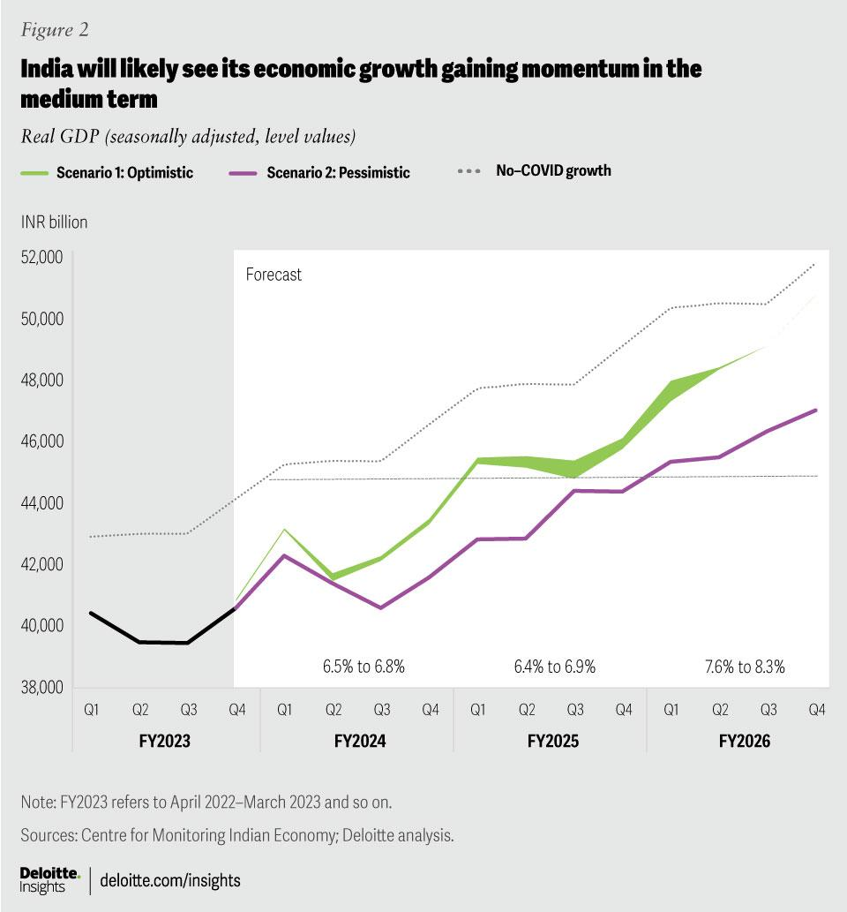

This study also endeavors to gauge the strength of the connections between the independent parameters and the dependent parameter, i.e., BSE Sensex, in both the short run and long run. This assessment utilizes tests such as Johansen Cointegration, Granger Causality, and the Vector Error Correction Mechanism. Through the application of the Vector Error Correction Model (VECM), the analysis confirms the existence of a long-run causality between macroeconomic variables (IIP, inflation, interest rates, gold prices, exchange rates, FII, and money supply) and BSE Sensex. Additionally, it establishes short-run causality between inflation and BSE Sensex, as well as between money supply and BSE Sensex. Importantly, the results highlight that BSE Sensex influences changes in exchange rates, money supply, FII, gold prices, and IIP.

**Policy and Regulatory Framework**

Significant changes encompass: expanding foreign equity limits in various sectors; easing the most burdensome aspects of the Foreign Exchange Regulation Act; permitting automatic approvals for Foreign Direct Investment (FDI) in most sectors; implementing tax adjustments; liberalizing capital markets; and deregulating interest rates.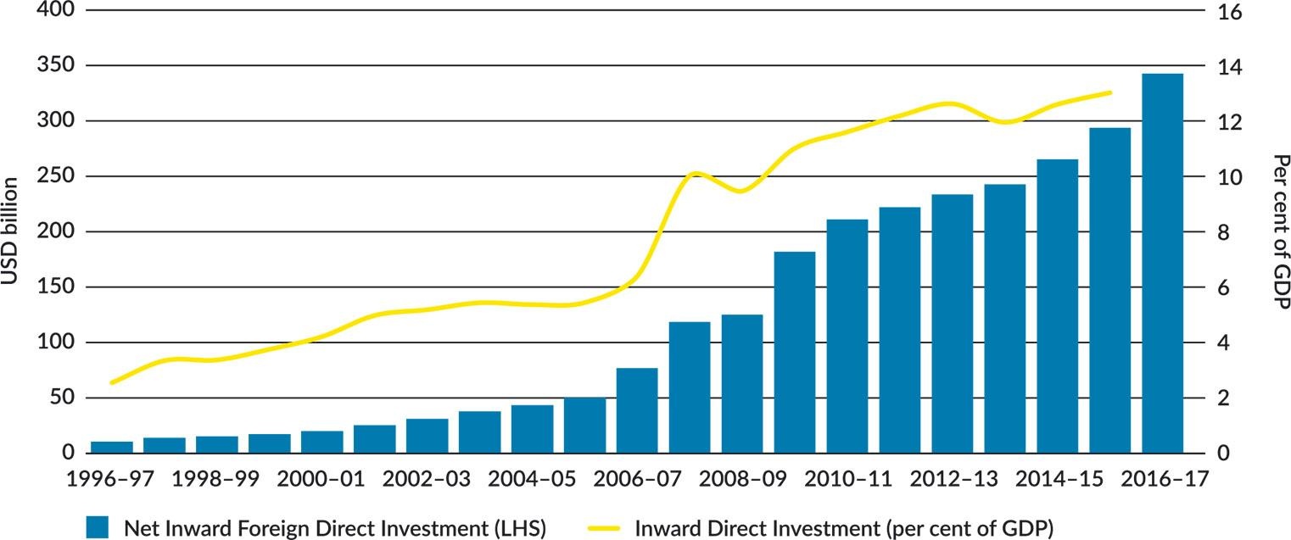

These patterns have led to India drawing investments from 155 countries spanning April 2000 to March 2017, spanning various sectors, with a notable emphasis on manufacturing and communication services.22 States that are well-developed and inclined towards reform, such as Maharashtra, Delhi National Capital Territory, Karnataka, Tamil Nadu, Gujarat, and Andhra Pradesh, have secured over 70 percent of these inflows since 2000.22

Invest India, the nation's investment promotion agency, is committed to encouraging and facilitating both inbound and outbound direct investments while contributing policy insights to Foreign Direct Investment (FDI) frameworks. Collaborating with Indian states, Invest India offers guidance on refining their competitive strengths to attract foreign investors.

Presently, most FDI applications are channeled through a single-window portal managed by the Department of Industrial Policy and Promotion, subject to mandatory approval stipulations. Across various sectors, constraints such as foreign equity limits, divestment conditions, and lock-in periods are being eased.

Despite these advancements, substantial challenges persist in transforming potential FDI in India into tangible investments on the ground, especially in sectors where they are most needed. The three primary limiting factors include:

1. India's complex business environment leading to a scarcity of commercially appealing projects, even in sectors fully open to investment. This is exacerbated by unpredictable government interventions.

2. Constraints on foreign investors in terms of equity, screening, and personnel.

3. Complete prohibition of FDI in certain sectors, such as legal and accounting services.

Examining Australian FDI trends in India, the direct investment relationship has historically been modest. Only 0.24 percent of India's total equity inflows since 2000 originated from Australia.22 This should be contextualized within the broader perspective of corporate Australia's generally low direct investment presence in Asia.

In 2017, India accounted for a modest 0.3 percent share (USD 1.8 billion) of total Australian direct investment stocks.21 In contrast, a conventional investment market like the United States hosted over 20 percent of Australia's outward FDI during the same year.

**Infrastructure Development**

The 2023–24 Union Budget is a comprehensive initiative focusing on infrastructure, development, and key sectors like real estate and industrial growth. With an unprecedented allocation of 10 trillion rupees to infrastructure development, the budget aims to enhance connectivity between cities and balance fiscal consolidation with economic growth.

This budget emphasizes responsible policies, increased budget allocations, and measures to improve India's business environment. It is expected to drive investments, job creation, and urban-rural connectivity while facilitating affordable housing and socio-economic services.

Key measures, such as expanding PM Awas Yojana and reducing income taxes, aim to boost low-cost housing availability. However, the emphasis on improving underlying infrastructure is crucial for the construction sector. The government's focus on "Green Growth" aligns with sustainable development goals, offering promise for a greener future and improved quality of life.

Significant allocations, including Rs 16,000 crores for "sustainable cities of tomorrow," highlight a long-term commitment to infrastructure development. The increased budget for the Urban Infrastructure Development Fund will accelerate urban infrastructure construction.

The budget's emphasis on Tier-2 and Tier-3 cities offers hope for overall infrastructure improvement, particularly in metro projects, sanitation, and urban housing. States incentivizing manufacturing in Tier 2 cities, part of industrial corridors, are anticipated to become future economic hubs.

The surge in demand for logistics parks and warehousing, extending beyond major cities to Tier 2 and Tier 3 cities, signals an industrial revolution. India's trajectory toward becoming the world's third-largest economy in a decade underscores the importance of infrastructure development in poverty eradication.

The government's substantial incentives for both traditional and digital infrastructure development align with India's journey as an emerging economic powerhouse on the global stage.

**Political Stability and Governance**

Political instability, defined as the risk of government collapse due to conflicts or intense political competition, is persistent and intricately linked with economic growth. An unstable political environment can reduce investment and economic development pace, while poor economic performance may lead to political unrest. However, achieving political stability through oppression or non-competitive ruling parties poses a dilemma, as it can become a breeding ground for cronyism.

Historically, political stability is not the norm, and democratic regimes, like all political regimes, are fragile. A country, regardless of its political regime, can focus on working, saving, and investing without concerns about conflicts and regime changes. Recent research on corruption identifies a connection between stability and reduced corruption, yet many countries combine stability with the opposite: politically stable autocracies or newly formed and unstable democracies.

Some view political stability as stifling change, demoralizing the public, and hindering innovation. Innovation and ingenuity may take a backseat, and the lack of competition in politically stable systems can lead to complacency and stagnation. Political stability, when enforcing stringent barriers to personal freedoms, press freedom, religious freedom, internet access, and political dissent, fosters abuse of power and corruption.

Examining Vietnam's case, a politically stable ruling party hasn't translated into economic stability, showcasing structural problems, inefficiency, and rising inflation. Similarly, some African states with stable political systems don't always correlate with high growth. Stable governance, emphasizing the rule of law, strong institutions, efficient bureaucracy, low corruption, and an investment-friendly business climate, is crucial for growth.

Long-term political stability with one ruling party can attract foreign direct investment but may lead to societal drawbacks like complacency and lack of competition. India's economic performance, illustrating lower growth in politically stable periods and higher growth with changing leadership, highlights that stable governments don't necessarily lead to higher economic growth.

In conclusion, not all forms of political stability equally foster development; the impact depends on the extent to which stability translates into good governance.

**Market Potential and Demographics**

India has become the world's most populous country, surpassing China, with a population of 1.4 billion, offering potential advantages amid declining birth rates globally. S&P Global Market Intelligence predicts India's population growth, and the UN estimates it won't decline for four decades.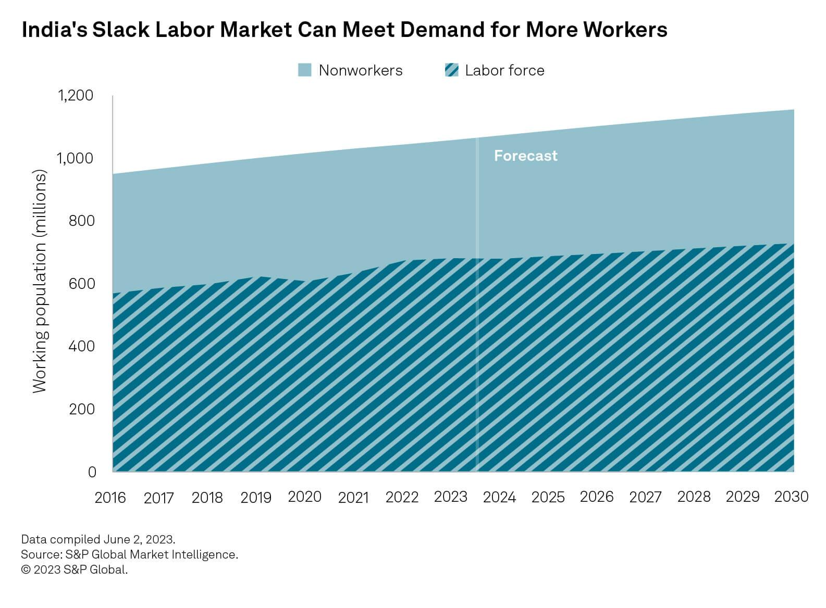

India's sizable workforce positions it to achieve domestic growth and benefit from global supply chain diversification. However, there's a need for accelerated labor upskilling and enhanced women's workforce participation to realize its economic potential.

Labor market slack supports India's manufacturing ambitions, aligning with the government's "Make in India, Make for the World" initiative. Despite being a services-oriented economy, India's untapped labor pool, coupled with relatively high unemployment, provides room for increased hiring. With a 9.3% unemployment rate in 2022 and an anticipated average of 11.0% over the next decade, India has the potential to attract more workers into the job market.

India's manufacturing is characterized by low-skilled labor, hindering its bid to be a global manufacturing hub. Skill development initiatives, like the Ministry of Skill Development and Entrepreneurship and the Skill India Mission, aim to address this gap. The National Education Policy further supports skilled workforce development, enabling India to attract high-value jobs in manufacturing and other sectors.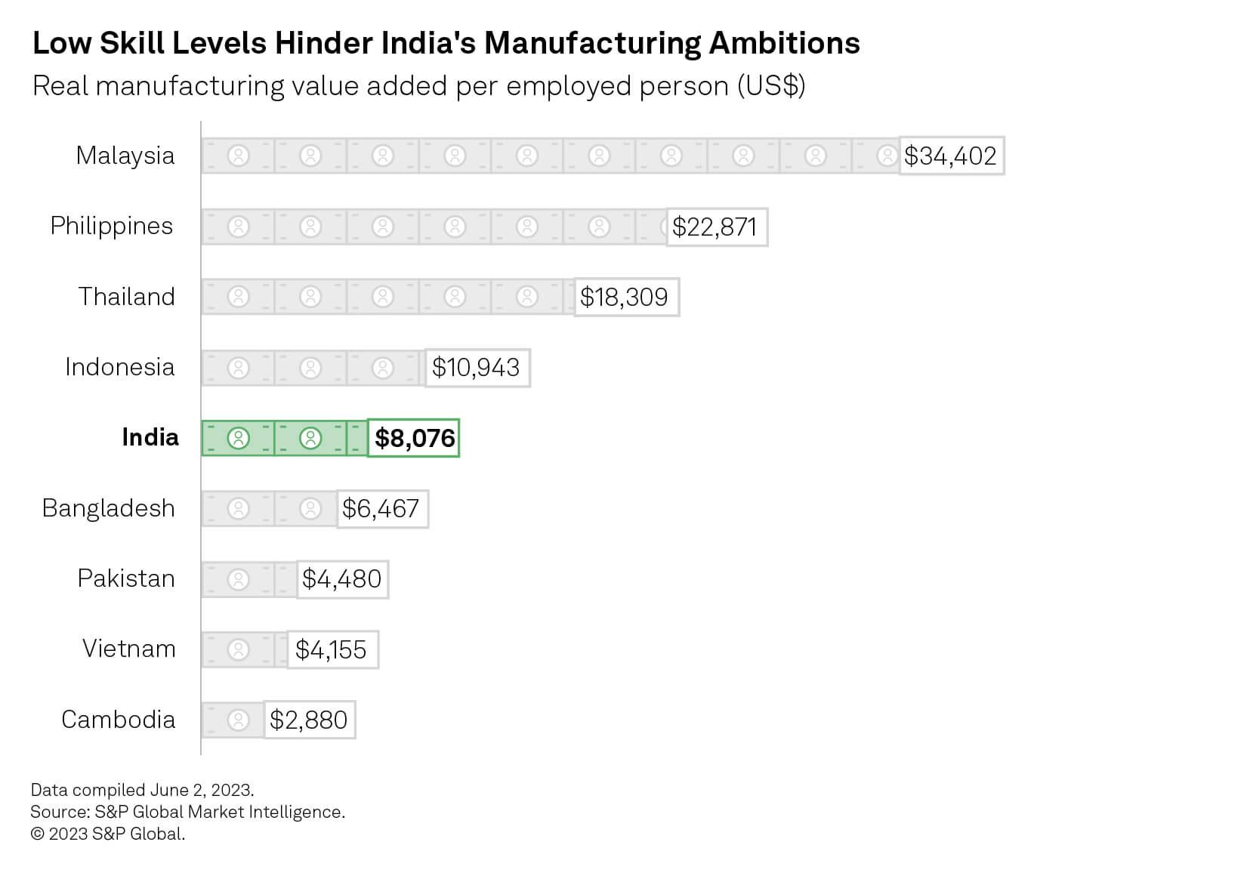

In essence, India's population advantage and untapped labor pool present opportunities for growth, but addressing skill gaps is crucial for realizing its potential as a global manufacturing hub.

**FDI Trends and Patterns**

The multifaceted role of foreign direct investment (FDI) in fostering economic growth is well-established globally. FDI also significantly contributes to the integration of global value chains, contingent on various factors such as regulatory policies, investment environment, competitiveness, market size, and political stability in host countries. The geopolitical shift in the world economy, coupled with assertive FDI promotion policies in key Asian nations, notably China and India, has redirected FDI flows towards Asia.

Amid the global economic upheaval caused by the COVID-19 pandemic, global FDI witnessed a sharp decline of over 42%, plummeting from approximately US$1.5 trillion in 2019 to an estimated US$859 billion in 2020. Notably, India and China defied this trend, experiencing positive growth in FDI flows. India saw a 13% increase, reaching an estimated US$57 billion, while China experienced a 4% rise, reaching an estimated US$163 billion.

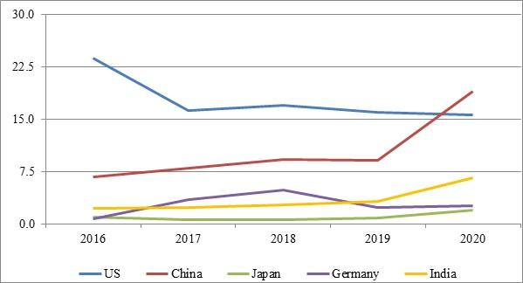

The US, traditionally the top recipient of FDI, faced a dramatic decline of over 49% in 2020, relinquishing its top spot to China. Despite this shift, the US is expected to regain its position once the pandemic is controlled and pre-pandemic economic growth is restored. The changing shares of major economies in global FDI flows over the last five years depict a decline in the US share, contrasting with an increase in the shares of India and China.

India has seen substantial growth in FDI inflows over the past five years, surpassing US$55 billion annually since 2015-16. The cumulative FDI received during 2015-2016 to 2019-20 exceeded US$312 billion, marking a 59% increase compared to the preceding five years. The surge in FDI to India in 2020-21,reaching approximately US$40 billion in the first six months, is indicative of a robust upward trend. The computer software and hardware sector has played a significant role in this surge, attracting FDI equity inflows of US$17.55 billion in the first half of 2020-21. Notably, equity constitutes about 70% of the total FDI received by India in 2019-20.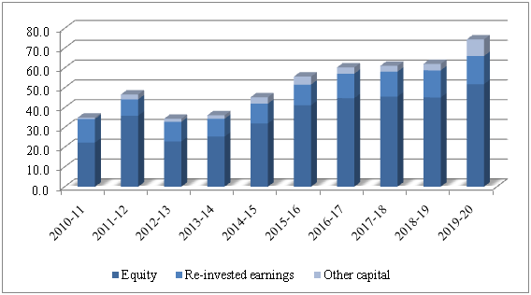

**Comparative Analysis: with china**

"Foreign Direct Investment (FDI)" is defined as "cross-border investment by a resident entity in one economy with the objective of obtaining a lasting interest in an enterprise resident in another economy. The lasting interest implies the existence of a long-term relationship between the direct investor and the enterprise and a significant degree of influence by the direct investor on the management of the enterprise."

While some emerging countries have experienced higher growth through Foreign Direct Investment (FDI) via Transnational Transactions, others have struggled to attract sufficient FDI for efficient growth. Despite India possessing favorable elements such as strong demographics and a large domestic market, China has proven more successful in attracting FDI.

Foreign investment has been a key factor in China's economic development for nearly a quarter of a century and remains crucial for its ongoing progress. Although China has been successful in attracting FDI and has made strides in enhancing its FDI policy framework, it has not fully tapped into its potential to attract FDI. As the second-largest recipient of FDI globally, China's success in this area surpasses that of India, which also boasts abundant labor pools and robust domestic markets. However, in the previous year, China received $111.7 billion in inbound FDI, while India received only $22.24 billion. It's noteworthy that China experienced a decrease in FDI for the first time in the preceding year.

**References**

<https://www.delhipolicygroup.org/publication/policy-briefs/fdi-flows-to-india-recent-trends-challenges-and-way-forward-2225.html>

<https://www.spglobal.com/en/research-insights/featured/special-editorial/look-forward/india-s-demographic-dividend-the-key-to-unlocking-its-global-ambitions>

<https://blogs.worldbank.org/endpovertyinsouthasia/can-political-stability-hurt-economic-growth>

<https://timesofindia.indiatimes.com/blogs/voices/infrastructure-and-investment-a-step-towards-the-industrial-revolution-in-india/>

<https://www2.deloitte.com/us/en/insights/economy/asia-pacific/india-economic-outlook.html>

<https://ro.uow.edu.au/aabfj/vol12/iss2/5/>

<https://www.dfat.gov.au/publications/trade-and-investment/india-economic-strategy/ies/chapter-2.html#:~:text=Notable%20reforms%20include%3A%20raising%20foreign,liberalisation%20and%20interest%20rate%20deregulation>.

<https://papers.ssrn.com/sol3/papers.cfm?abstract_id=2407914>